- This week's data offered very mixed signals on the pace of UK activity growth. Retail sales rose again in March, but the composite PMI plunged in April. In our view, both measures are deeply flawed. The retail data appears to suffer from seasonal adjustment problems, while the results of the S&P Global survey have been an unreliable predictor of changes in GDP growth.
- Comments from a couple of Monetary Policy Committee members suggest they regard recent US tariff announcements as a downside risk to growth and inflation. This offers some hope that the committee will be willing to set aside its supply concerns and adopt a more proactive approach to loosening policy.
On the face of it, the week's two main data releases – March's retail sales and April's flash S&P Global survey – provided very mixed signals on the current momentum in the economy. However, we have significant misgivings about both sets of results.
The Office for National Statistics reported that retail sales volumes rose 0.4% month-on-month in March. The increase came on the back of two strong m/m gains in January and February, and left sales volumes up 1.6% q/q across Q1 as a whole (Chart 1).
We think there's good reason to suggest this is overstating the performance of the retail sector. Virtually all the growth in the sector over the past year can be accounted for by the increase in sales in just the last three months. It was a similar story a year ago, with a very strong Q1 2024 coming after a drop in Q4 2023. We think the ONS is struggling to adjust the data in response to changes in the seasonal pattern of sales over time. The much later Easter this year likely added to these challenges – year-on-year sales growth in March was much higher on a seasonally adjusted basis than the non-seasonally adjusted data, suggesting the ONS's attempts to adjust for calendar effects had a key influence.
Given these problems, we should be cautious about estimates that are very strong in the first half of the year, as these are typically offset by more pessimistic readings in the last six months of the year.
Chart 1: Retail sales volumes rose again in March after another very strong increase in non-food sales
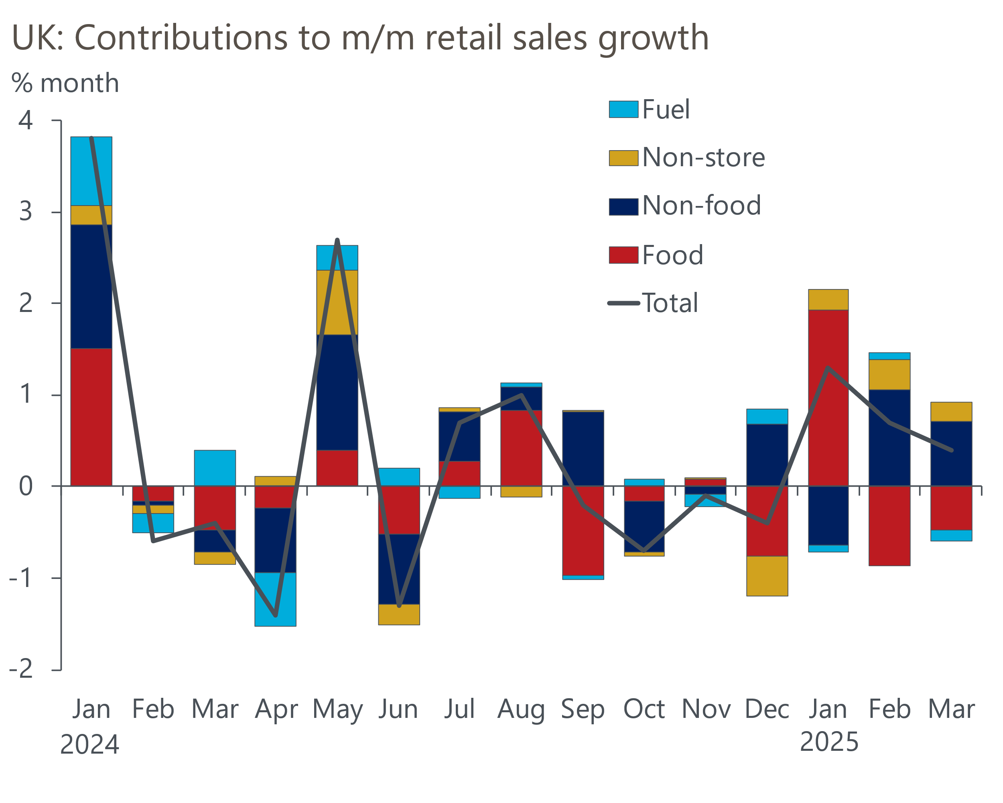
Source: Haver Analytics

In contrast, the week's second major release saw the flash S&P Global survey report a sudden contraction in activity in April. The composite PMI plunged to 48.2, from 51.5 in March. The decline was largely driven by the services balance falling to 48.9 from 52.5, with respondents citing rising global economic uncertainty and weak domestic demand conditions as the main driving forces. Meanwhile, the survey also reported a further deterioration in manufacturing production.
Historically the PMIs have enjoyed a strong reputation as a leading indicator of GDP growth. But our analysis finds this isn't backed by the data – the composite PMI is actually a poor leading indicator of GDP growth (Chart 2). There are several reasons for this. The survey only has partial sectoral coverage. Respondents are only asked if activity was higher, unchanged, or lower, so while the survey can often be directionally accurate, it is much weaker on the magnitude of changes. Furthermore, the survey results in practice tend to reflect swings in business sentiment rather than genuine trends in private sector activity.
Chart 2: The predictive capability of the composite PMI is weak and has declined over time
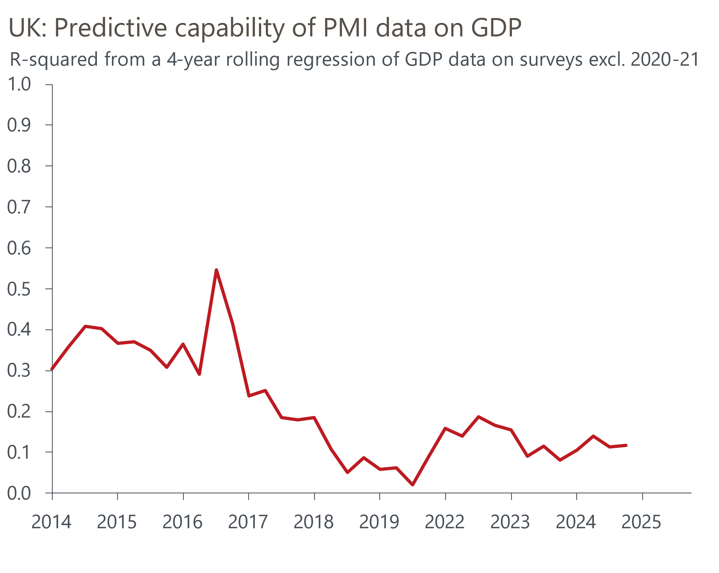
Source: Oxford Economics calculations using data from Haver Analytics and S&P Global
With April seeing a flurry of tariff announcements by the US government and increases in employers' national insurance contributions and the national living wage coming into effect, we think the collapse in the PMIs was heavily sentiment driven. We doubt activity is genuinely contracting sharply, and a broader sweep of the data suggests growth over the first few months of 2025 has likely been positive but modest.
This week saw a couple of Monetary Policy Committee members shed some light on how recent trade developments have affected their views. Bank of England Governor Andrew Bailey placed particular emphasis on the potential hit to growth. Speaking at an Institute of International Finance event in Washington on Wednesday, he said the committee "have to take very seriously the risk to growth". In a separate interview with CNBC on Thursday, he doubled down on this message, remarking that "we are certainly quite focused on the growth shock".
Megan Greene's lingering concerns over the economy's supply side means she has consistently been at the more hawkish end of the committee in recent months. However, in an interview with Bloomberg on Tuesday, she said that "tariffs actually represent more of a disinflationary risk than an inflationary risk".
We've argued that the tariff announcements are a classic demand shock that demands looser policy. But we've been concerned that the MPC's worries about constrained supply would lead them to adopt a cautious approach. This week's comments appear to indicate that the MPC is open to a more proactive approach, particularly given that Bailey tends to be a reliable bellwether of MPC sentiment. A 25bps rate cut in May is virtually a done-deal, but we'll be looking for indications in the minutes and press conference of whether the MPC is prepared to set aside its supply concerns and cut faster in an attempt to shore up demand.

The week ahead
We expect March's Money & Credit release to show another decrease in mortgage approvals. Mortgage demand was boosted in Q4 2024 by buyers looking to transact before the temporary rise in stamp duty thresholds expired at the end of March. But given the amount of time it takes to complete a purchase, activity started to fall back in the first two months of this year as the deadline approached. We expect to see further payback in March, so we have pencilled in a fall in approvals to 63,500, from 65,500 in February.
Gross mortgage lending and repayments grew strongly in February. We expect gross lending to have risen further in March, as purchases looking to beat the stamp duty deadline were completed. There's a good chance that repayments normalised in March, so we anticipate a spike in net secured lending to £6.4bn, from £3.3bn a month earlier.
Net unsecured lending has been relatively erratic in recent months, reflecting volatility in repayments. We expect net unsecured lending to have fallen modestly to £1.2bn in March.
April's flash manufacturing PMI fell to a 20-month low of 44.0, following reports of lower production and a deteriorating pipeline of new orders from abroad amid greater US trade uncertainty. With no clear pattern of revisions, we think the final results will be close to this week's flash survey.
Table 1: Week ahead calendar
Date | Events | Period | Measure | Unit | Previous | Forecast
May 1 | Nationwide house prices | Apr | m/m | % | 0.0 | 0.1
May 1 | Nationwide house prices | Apr | y/y | % | 3.9 | 4.3
May 1 | Mortgage approvals | Mar | Level | 000s | 65.5 | 63.5
May 1 | Mortgage lending | Mar | Net lending | £bn | 3.3 | 6.4
May 1 | Consumer credit | Mar | Net lending | £bn | 1.4 | 1.2
May 1 | S&P Global manufacturing | Apr | PMI | % bal | 44.0 | 44.0
Source: Oxford Economics

Key forecasts
Table 2: UK forecast overview
(Annual percentage changes unless specified)
 | 2022 | 2023 | 2024 | 2025 | 2026 | 2027
GDP | 4.8 | 0.4 | 1.1 | 1.0 | 0.9 | 1.3
Private consumption | 7.3 | 0.5 | 0.6 | 1.2 | 1.1 | 1.2
Fixed investment | 5.1 | 0.3 | 1.5 | 1.0 | 1.0 | 1.6
Government consumption | 0.6 | 1.6 | 3.0 | 2.3 | 1.2 | 1.5
Exports of goods and services | 12.6 | -0.4 | -1.2 | 0.6 | -1.2 | 1.2
Imports of goods and services | 13.0 | -1.2 | 2.7 | 0.8 | -0.4 | 1.1
Industrial Production | -6.4 | -0.8 | -1.2 | -0.2 | -0.3 | 0.7
Consumer prices | 9.1 | 7.3 | 2.5 | 3.0 | 2.4 | 2.3
Unemployment rate (%) | 3.8 | 4.1 | 4.3 | 4.6 | 4.9 | 4.8
Current a/c balance (% of GDP) | -2.2 | -3.5 | -2.7 | -2.6 | -2.8 | -2.6
Government balance (% of GDP) | 4.3 | 5.2 | 5.0 | 3.5 | 3.3 | 2.7
Central bank policy rate (%, EOP) | 3.50 | 5.25 | 4.75 | 3.75 | 3.00 | 2.50
10yr govt. bond yield (%, EOP) | 3.67 | 3.54 | 4.57 | 4.54 | 3.95 | 3.44
Exchange rate (US$ per £, EOP) | 1.20 | 1.27 | 1.25 | 1.29 | 1.29 | 1.29
Exchange rate (euro per £, EOP) | 1.13 | 1.15 | 1.21 | 1.17 | 1.17 | 1.17
Source: Oxford Economics
Table 3: Quarterly forecasts for the UK
 | 2025 |  |  |  | 2026
 | Q1 | Q2 | Q3 | Q4 | Q1 | Q2 | Q3 | Q4
GDP (% year) | 1.1 | 0.9 | 1.0 | 1.1 | 0.7 | 0.8 | 0.9 | 1.0
CPI inflation (% year) | 2.8 | 3.1 | 3.3 | 3.0 | 2.8 | 2.3 | 2.3 | 2.4
Bank Rate (%, EOP) | 4.50 | 4.25 | 4.00 | 3.75 | 3.50 | 3.25 | 3.25 | 3.00
10yr gilt yield (%, EOP) | 4.70 | 4.70 | 4.63 | 4.54 | 4.40 | 4.25 | 4.09 | 3.95
US$ per £ (EOP) | 1.29 | 1.29 | 1.29 | 1.29 | 1.29 | 1.29 | 1.29 | 1.29
Euro per £ (EOP) | 1.20 | 1.17 | 1.17 | 1.17 | 1.17 | 1.17 | 1.17 | 1.17
Source: Oxford Economics

Latest Country Economic Forecast:
April 16, 2025

Recent publications

Data Insights
Retail's strong start to 2025 may not last
April's flash PMIs plunged amid elevated trade uncertainty
Tariffs pose a big challenge to the fiscal arithmetic
Inflation fell again in March, but a sharp rebound is likely
Labour market not making life easy for the MPC

Research Briefings
Higher tariffs damage growth prospects
Trump tariffs will cut UK growth as global demand weakens
Stopgap Spring Statement leaves problems unresolved
Will (mild) stagflation continue?
Why official data are less reliable and what this means

Contacts

Oxford Economics' UK team
- Andrew Goodwin - Chief UK Economist - agoodwin@oxfordeconomics.com
- Edward Allenby - UK Economist - eallenby@oxfordeconomics.com

